PRESS RELEASE
Foster by the Spanish company EasyFeedback
EasyFeedback Token is born, the first cryptocurrency that rewards communication between users and companies via blockchain.
The innovative proposal of this website with more than 270,000 registered users consists of rewarding consumers with crypto currencies for sending private and constructive feedback to companies all over the world.
EasyFeedback.com, the website whose mission is to promote feedback among consumers and companies so that they can achieve excellence and improve their sales and reputation, arrives to the blockchain technology. This technology at the service of the consumer proposes an innovative concept around feedback. "We make it easy for companies to capture and manage user´s feedback privately and not anonymously. In this way, the improvement of the companies is promoted with the voice of the customers' experience, generating an environment of mutual trust and commitment. We prevent both companies and consumers from turning feedback into a weapon, as is the case with other websites, apps and social networks," said Honorio Ros, CEO of EasyFeedback.
Rewarding constructive feedback through tokens
The blockchain technology will allow EasyFeedback to reward the feedback sent by a user (suggestion, complaint or greeting) to a company through its platform using a token or cryptocurrency (EasyFeedbackToken "EFT"). It will also allow new products to be created for companies and consumers based on the analysis of the data obtained.
EasyFeedback Token - based on the Etherum blockchain - will be an ecosystem where the following actors will be integrated:
- Feedback writers: They are the users who generate feedback and want to be rewarded for doing so. With the launch of our "EFT", cryptocurrency, which will reward the sending of feedback, the number of users will increase considerably.
- Companies: Those committed companies that want to keep a fluid communication with their clients will integrate the platform. They will be rewarded with "EFT" for the feedback received.
- Validators/oracles: The blockchain technology will allow to make objective evaluations about the quality and reliability of the feedback. To achieve this, we will use manual validation nodes/oracles: internal, company and lawyer. Validator nodes/oracles will communicate with the regulator node, which is the one that inserts us into the blockchain.
Sale of EasyFeedback Token “EFT”
Easyfedback.com before starting the tokenization project of its platform has invested a capital of 730.000$ to finance the development of the project. "With EasyFeedback Token we will take advantage of blockchain technology to improve the service we already offer and extend the advantages of our solution for the benefit of both consumers and businesses," says Ros.
The total number of "EFT" tokens in existence is 179,141,000,000 which are already pre-mined and will not be generated any further. The sale of less than 1% of the tokens will be used for the adaptation of the current business model to the blockchain and its internationalization. The rest, more than 99%, is reserved to reward users who send constructive feedback over time.

More information:
- Contact person: Honorio Ros - hros@easyfeedbacktoken.io
- Locations:
- Polígono Mutilva Baja en Calle V Nº26 – 31192 Mutilva Baja (Navarra) Spain
- Harju maakond, Tallinn, Lasnamäe linnaosa, Lõõtsa tn 5-11, 11415
- EasyFeedback Token web: https://www.easyfeedbacktoken.io/en/
- Essentials post of "EFT": https://easyfeedbacktoken.io/easyfeedback-token-essentials/
- EasyFeedback Token “EFT” was created to reward people who from https://www.easyfeedback.com/index_EN.html communicate useful and private feedback to improve products, services and processes of companies and institutions. "EFT" can be exchanged for products, services, cryptocurrencies or money at a market price.
- More than 270.000 users have already sent their private feedbacks to more than 10,000 companies in 50 different countries and their business products are already being used by companies. Working product since 2015 we send 200/300 feedback daily just in spanish.
- People who acquire EasyFeedback token will benefit from a bonus on the price of the EFT token during the different phases of the Pre-Sale and IEO launch (with a bonus ranging from 10% to 40%, depending on the phase at which the investment is made). Annually, the EFT holders will be rewarded with additional EFT.
- Social networks:
· Telegram English: 10.000 > https://www.t.me/EasyFeedbackToken
· Facebook: 1.500 > https://www.facebook.com/EasyFeedbackToken
· Twitter @EasyFeedback: 4.000 > https://twitter.com/EasyFeedback
· LinkdIn: 1.000 > https://www.linkedin.com/company/easyfeedbackpro/about/
· BITCOINTALK: https://bitcointalk.org/index.php?topic=5155778.0
· Reddit: https://www.reddit.com/user/EasyFeedback
. Github: github.com/easyfeedback-token
. Etherscan: https://etherscan.io/token/0x3ee2fd8e38a16f06ab85d684e062c0cf7d0e9a8b
. Icomarks: https://icomarks.com/ico/easy-feedback-token
- EasyFeedback Token "EFT" Ecosystem Video: https://www.youtube.com/watch?v=kO6BLx_g5lw
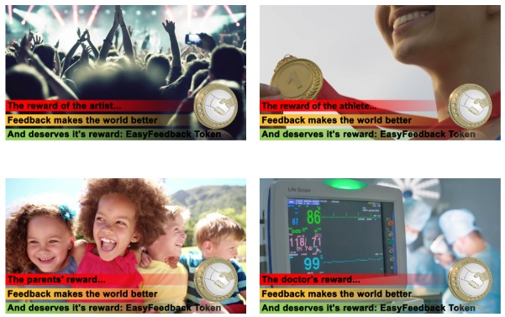
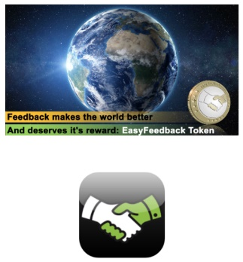
- Visit our media section to get images of EasyFeedback Token https://easyfeedbacktoken.io/press-kit-easy-feedback-token/

The Feedback Moves The World and Deserves it´s Reward!

